Tree Data Structure (Level 0 to Level 4 Example)
A Tree is a non-linear data structure where nodes are connected using edges. The diagram below represents a tree with 5 levels starting from Level 0 to Level 4.
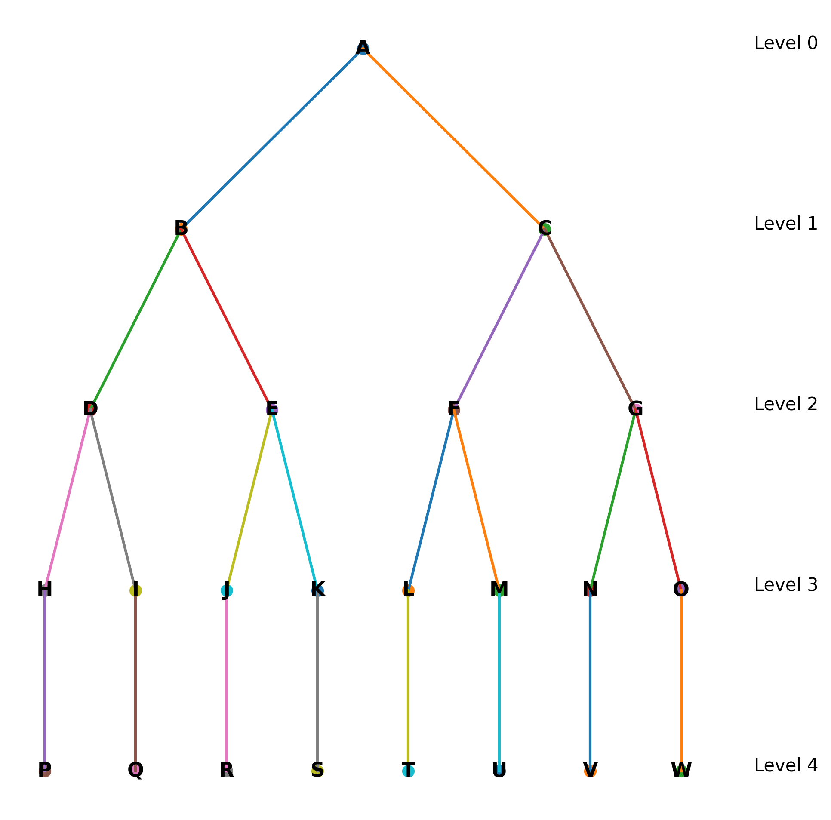

Levels in the Tree
Level 0 : A (Root Node)
Level 1 : B, C
Level 2 : D, E, F, G
Level 3 : H, I, J, K, L, M, N, O
Level 4 : P, Q, R, S, T, U, V, W

Tree Terminologies Explained Using the Diagram
- Node: Each element in the tree such as A, B, C etc.
- Root Node: The topmost node of the tree. In this example, A.
- Parent Node: A node that has children. Example: B is parent of D and E.
- Child Node: Nodes connected below a parent node. Example: D and E are children of B.
- Siblings: Nodes with the same parent. Example: B and C (Parent A), J and K (Parent E) are siblings
- Leaf Node: Nodes without children such as P, Q, R, S, T, U, V, W.
- Internal Node: Nodes that have at least one child such as B, C, D, E, F, G.
- Path: Sequence of nodes from one node to another. Example: A → B → D → H → P.

To understand the Tree Data Structure properly, we need to understand tree’s characteristics and some other terminologies.
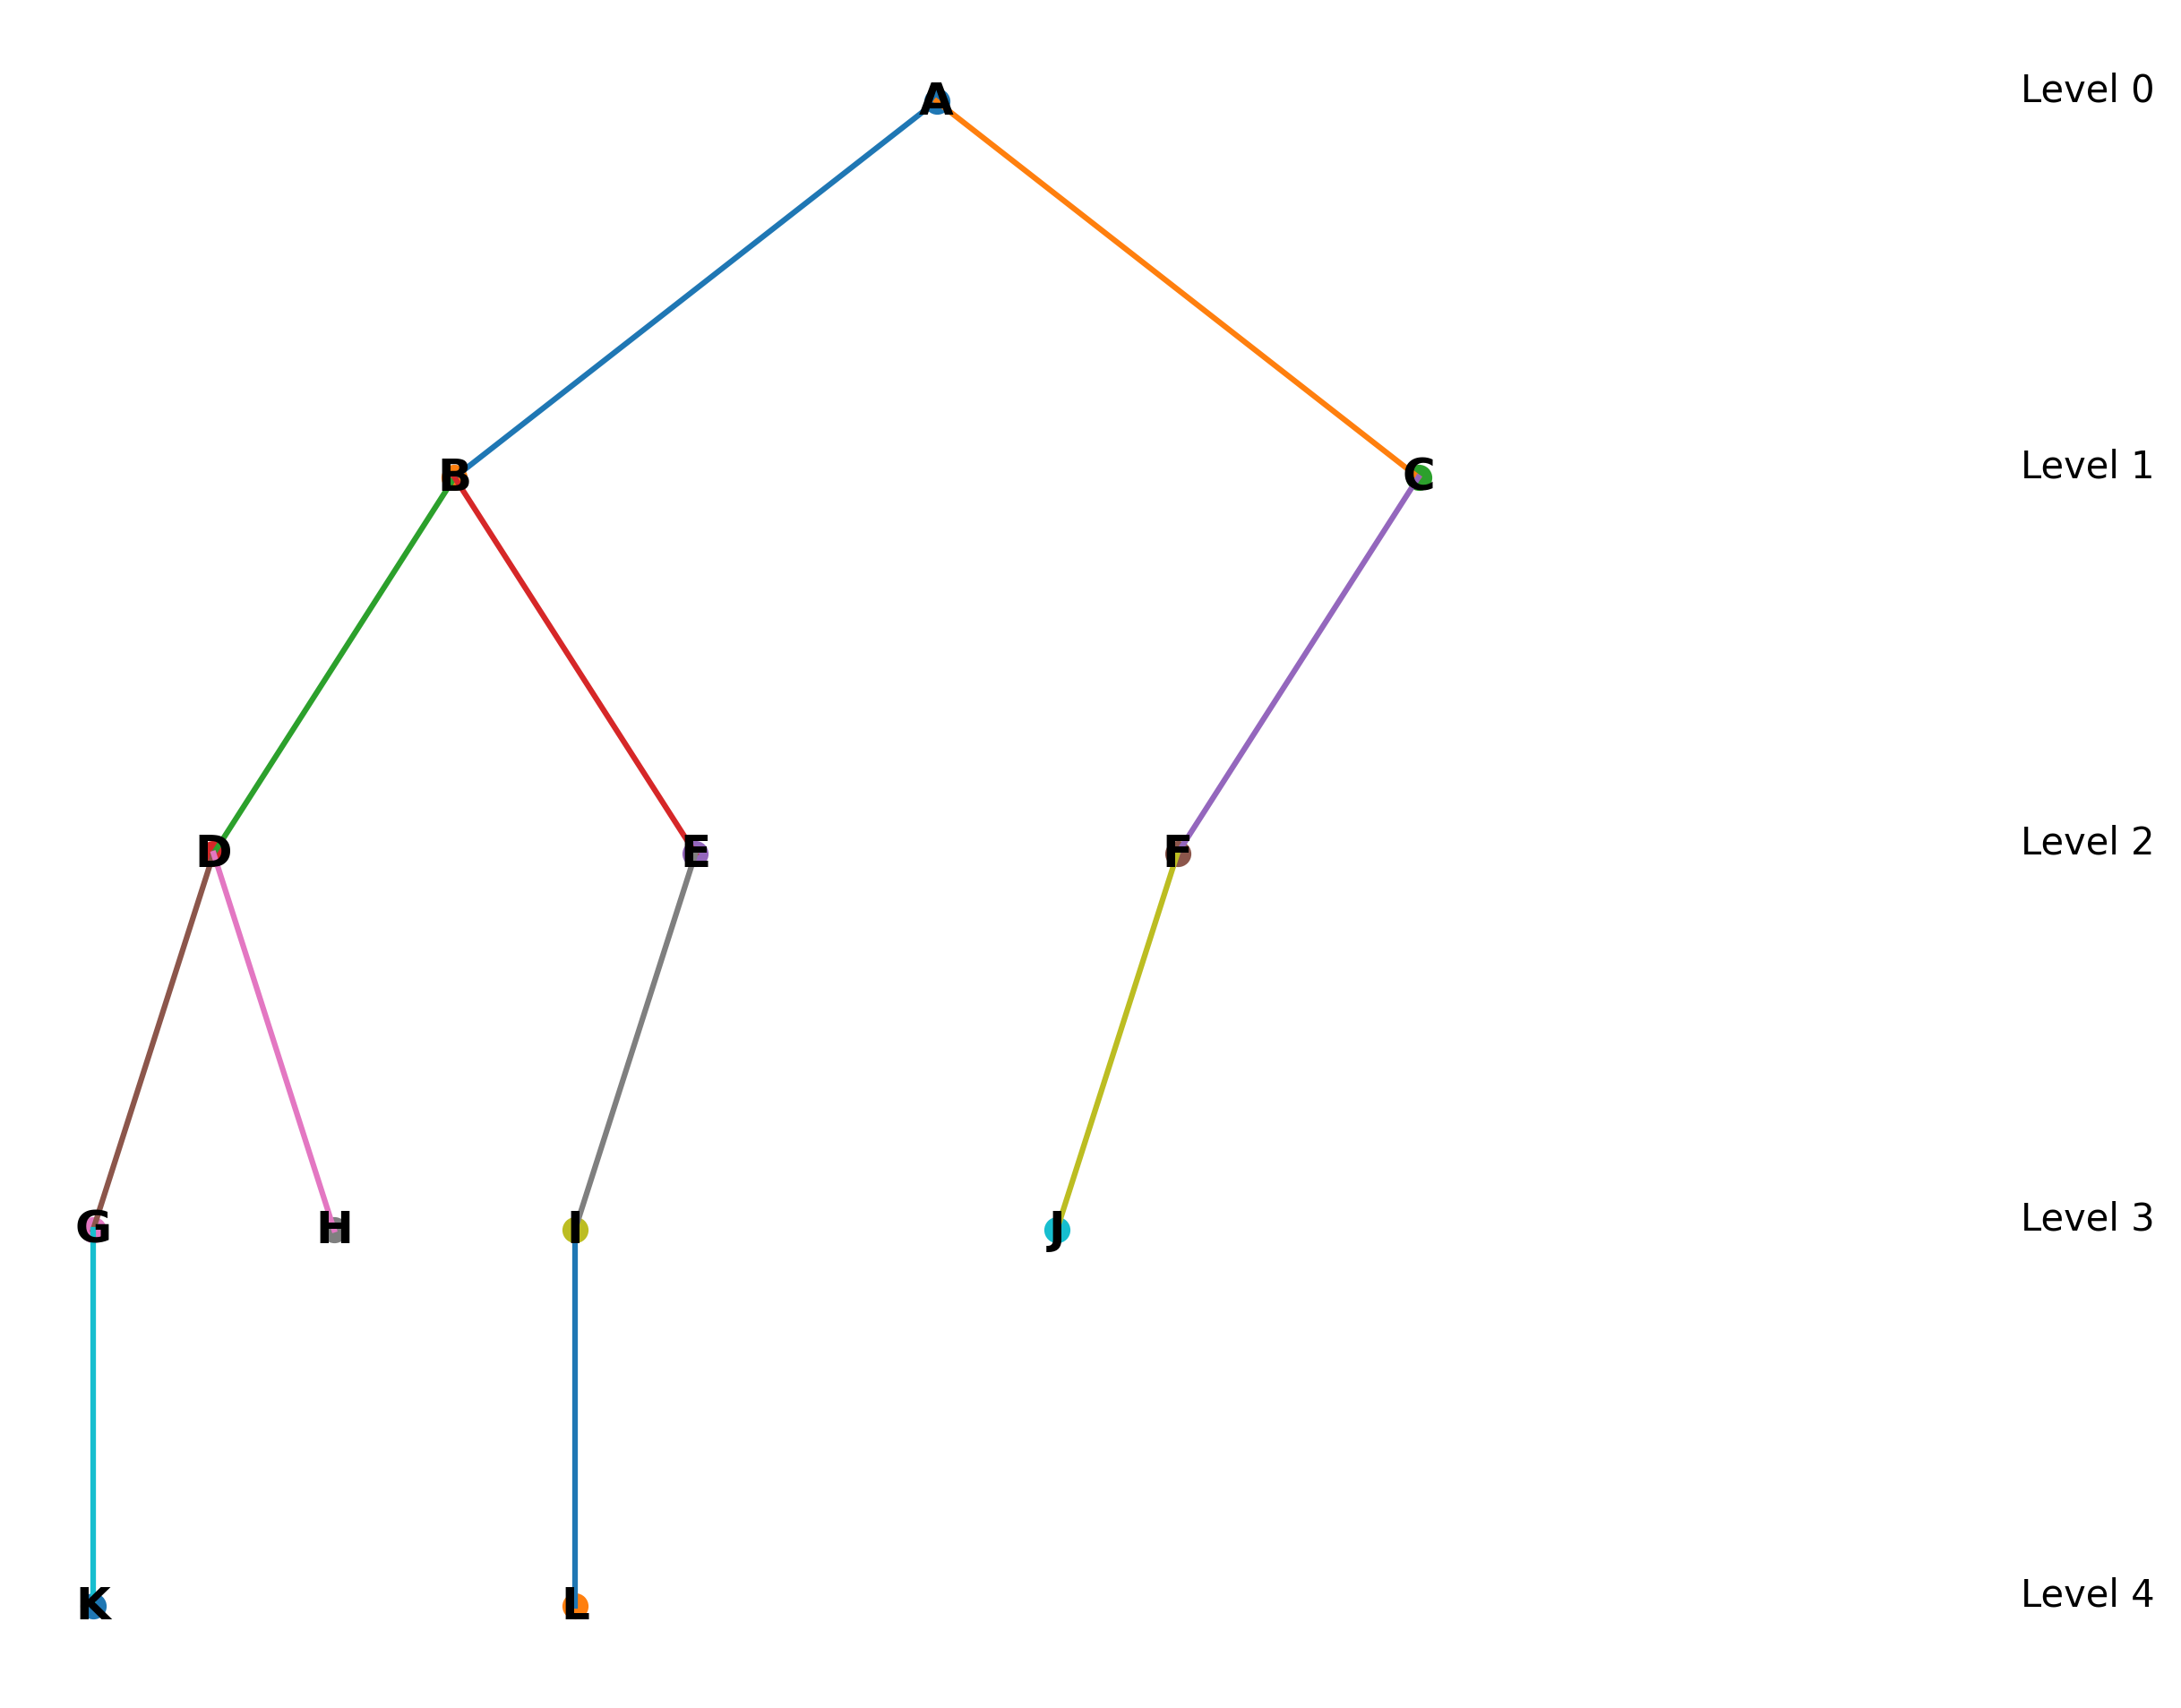

Characteristics of Tree Data Structure
1. A tree can have only one root node.
2. If a tree has n nodes, it will always have (n - 1) edges.
3. A child node can have only one parent, but a parent node can have multiple children.
4. Tree is a recursive data structure.
5. A tree is a collection of sub-trees.
6. In the above example, B → D,E and C → F are subtrees where B and C act as roots of their own subtrees.

Degree
Degree of a Node: Number of children of that node.
- Example: Node B has children D and E. Therefore Degree(B) = 2
Degree of a Tree: Highest degree among all nodes in the tree.
- Example: If node D has 2 children and node B has 2 children, the highest degree is 2. Therefore, Degree of Tree = 2.

Level
Level of a node represents its position in the tree starting from the root.
Level starts from 0.
Example:
Level 0 : A
Level 1 : B , C
Level 2 : D , E , F
Level 3 : G , H , I , J
Level 4 : K , L

Height
Height of a Node: Number of edges in the longest path from that node to a leaf node. Count edges starting from 1
Example: For node C → F → J. Number of edges = 2. Therefore Height(C) = 2.
Height of Tree: Height of the root node.
Height of leaf nodes is always 0.

Depth
Depth of a Node: Number of edges from root node to that node.
Example: Path A → B → D → G
Number of edges = 3. Therefore Depth(G) = 3.
Depth of root node is always 0.
Depth of Tree: Maximum depth among all nodes.

Types of Trees
1. General Tree: A node can have any number of children.
2. Binary Tree: A node can have at most two children (0, 1 or 2).
Next Session: Different Types of Binary Trees.

Types of Trees
1. General Tree – A node can have any number of children.
2. Binary Tree – Each node can have at most two (0, 1 or 2) children.
Next Session: Different Types of Binary Trees

